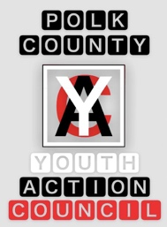
Polk County Youth Action Council Leadership Meeting
March 2024

Vision: All people in Polk County will have a safe, supportive, and stable place to call home.

Mission: The Youth Action Council’s mission is to empower and motivate our community to be the change by ending the stigma and stereotypes associated with homelessness, connecting at-risk youth with resources, and promoting compassion within our community.

Welcome/Introductions
Presentation
Staff reviewed the PowerPoint with YAC going over each section. Some suggestions were: homelessness and prison/recidivism, covid effects, and that while housing may be stable a job might not be, add examples of criminalization of homelessness. YAC members contributed thoughts and quotes to the “our experiences” section.
Amy updated YAC that the Spark presentation application was accepted and that will occur on Thursday July 25th 9-10:20.
Website
YAC was asked to think about giving some quotes/testimonials as the final step before the website goes live.
YHDP Work group Meeting - April 10, 10-12pm, River Place
YAC was informed about the YHDP meeting.
Youth Service Networking event – April 22, 3-5 pm, Full Circle Recovery
YAC was informed about helping run this event.
Reminders for these events and signup will be sent out closer to the date.
Future Meeting: Anawim’s new program feedback
Anawim will be joining YAC at either March or April’s general meeting to get some insight and feedback from YAC as they move towards starting a new program.

